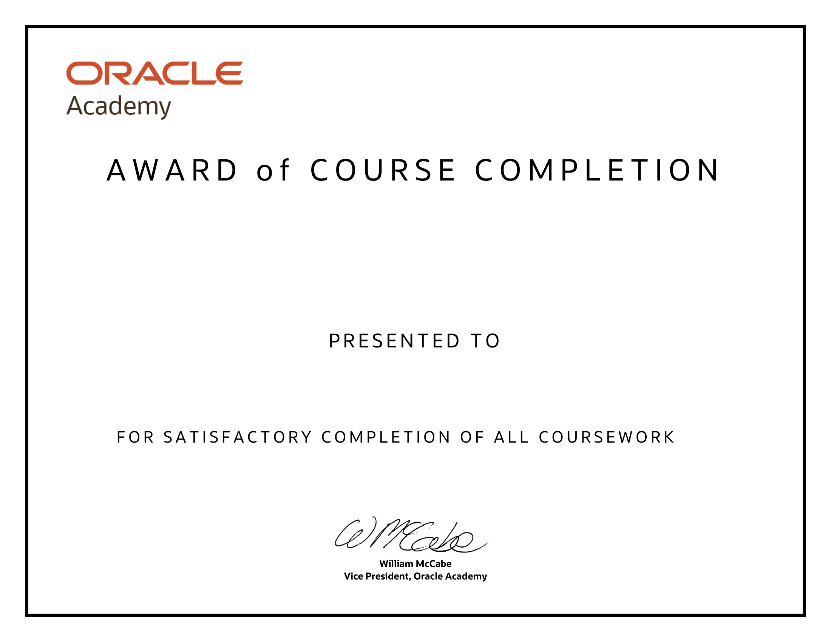

SIBISUNDAR L 220701277

Database Programming with SQL

11th April 2024